Asymmetry in the Inheritance of Centrosomes/Centrioles and Its Consequences

2025
Vol.1 No.2:4

Longevity Horizons
ISSN: 2960-9011

Jaba Tkemaladze*

Longevity Clinic, 46 Shota Rustaveli Street, 3001, Resort Abastumani, Georgia
Received date: February 1, 2025; Accepted date: February 6, 2025; Published date: February 8, 2025
*Corresponding author: Tel: +995 555 185161; E- mail: jtkemaladze@longevity.ge
Copyright: © 2025 Tkemaladze Jaba. This is an open-access article distributed under the terms of the Creative Commons Attribution License, which permits unrestricted use, distribution, and reproduction in any medium, provided the original author and source are credited.
Citation: Tkemaladze, J. (2025). Asymmetry in the Inheritance of Centrosomes/Centrioles and Its Consequences. Longevity Horizons, 1(2). doi: https://doi.org/10.5281/zenodo.14837352

Abstract
Asymmetric division of stem cells plays a fundamental role in maintaining tissue homeostasis by ensuring a delicate balance between self-renewal and differentiation. Within this process, the centrosome and its components, including centrioles, exhibit both functional and structural asymmetry.

The mother and daughter centrioles are inherited in a stereotypical manner, influencing the fate of sibling cells. The mother centriole, possessing a higher microtubule-organizing capacity, often remains in the stem cell, while the daughter centriole is transmitted to the differentiating progeny.

This mechanism has been observed in germline stem cells of Drosophila and radial glial cells in mammals. However, in Drosophila neuroblasts, an opposite strategy is maintained: the daughter centriole remains in the stem cell, whereas the mother centriole is passed on to the progenitor cells.

These differences may be linked to the regulation of cell fate, aging, and tissue longevity. A deeper understanding of the role of centrioles in these processes could pave the way for new approaches in regenerative medicine and anti-aging therapies.

Keywords: centrosome, centrioles, stem cells, asymmetric division, progenitor cells, sibling cells

Introduction

Centrosomes/centrioles are not essential for cell division (Khodjakov et al., 2000), and it has been demonstrated that an entire organism (fruit fly) can develop without functional centrosomes/centrioles (Basto et al., 2006). Despite these observations, a substantial body of evidence supports the notion that centrosomes play a crucial role, primarily due to their ability to organize microtubules and cilia (Conduit et al., 2015). Indeed, abnormalities in centrosome number and function are associated with severe human diseases, including ciliopathies and cancer (Nigg, E. A., & Raff, J. W., 2009).

One of the most critical functions of the centrosome is its involvement in asymmetric cell divisions. Asymmetric divisions are achieved by cellular polarization relative to fate determinants in conjunction with spindle orientation (Sunchu, B., & Cabernard, C., 2020). As the primary microtubule-organizing center (MTOC) during interphase and mitosis, the centrosome can exert significant influence over cell polarity and spindle orientation.

Within a given cell, centrosomes/centrioles inherently exhibit asymmetry, with one centrosome/centriole always being older (the mother centriole) than the other (the daughter centriole). These structures differ in MTOC activity, with various types of stem cells exhibiting stereotypical inheritance of the older mother centriole. This has led to the hypothesis that the centrosome may regulate asymmetric cell divisions by directing cell polarization and potentially carrying critical information that influences the fate of sibling cells.

Asymmetry in Duplication
The centrosome serves as the MTOC in animal cells, and its number per cell is tightly regulated through a precise duplication cycle. Conceptually, centrosome duplication during the cell cycle is similar to DNA replication. A pair of centrioles resides at the core of the centrosome, duplicating by using pre-existing centrioles as templates (Fu et al., 2015). Similar to DNA, centrioles duplicate once per cell cycle in a semiconservative manner: the centriole pair dissociates before the G1-S transition, with each centriole acting as a template for a new centriole (Nigg et al., 2018). This process results in two centrosomes, each containing one template centriole and one newly formed centriole.

In the early G1 phase, cells contain a single centrosome comprising two orthogonally aligned centrioles surrounded by pericentriolar material (PCM). The mother centriole, which served as a template in the previous cycle, can be distinguished from the daughter centriole by its distal and subdistal appendages. Before the G1-S transition, the tight association between the mother and daughter centrioles is loosened (centriole disengagement), but they remain connected by a fibrous linker. During the G1-S transition, each centriole initiates the formation of new daughter centrioles. The previous daughter centriole matures into a mother centriole but is not yet fully competent to acquire appendages. New daughter centrioles elongate by the end of the G2 phase, and the two centrosomes (each containing a mother and a daughter centriole) separate before mitotic entry. During mitosis, the mother and daughter centrosomes organize the mitotic spindle and are distributed into two daughter cells.

The semiconservative nature of centriole duplication generates internal asymmetries in two key ways. First, within each centrosome, one centriole (the template, or mother centriole) is older than the other (the newly duplicated daughter centriole), establishing an age-related asymmetry. Second, once the cell contains two centrosomes (i.e., two pairs of centrioles) following duplication, the mother centrioles in each centrosome differ in age, as one was a template in the previous cell cycle. The differing ages of these mother centrioles render the centrosomes distinct: the centrosome containing the older mother centriole is referred to as the mother centrosome, whereas the one with the younger mother centriole is termed the daughter centrosome.

Mother and daughter centrioles can be distinguished by their ultrastructure, function, and molecular composition. In mammalian cells, only the mother centriole possesses distal and subdistal appendages and can function as a basal body for cilia formation, whereas the daughter centriole lacks these structures (Kumar, D., & Reiter, J., 2021). Subdistal appendages develop as centrioles mature and serve as key sites for microtubule anchoring. Since it takes more than one cell cycle for the mother centriole to acquire appendages and fully mature, the mother centrosome, containing the older mother centriole, typically exhibits higher MTOC activity than the daughter centrosome, which contains the newly matured centriole. This creates a functional asymmetry between mother and daughter centrosomes. Several proteins, such as Ninein (Nin), Cep164, and outer dense fiber protein 2 (ODF2), localize to the mother centriole, whereas Centrobin (Cnb) is exclusive to the daughter centriole (Lange, B. M., & Gull, K., 1995), generating molecular differences between the two structures. While centrioles in species like Drosophila and C. elegans lack the appendages found in mammalian cells, mother centrosomes in these organisms still exhibit higher MTOC activity than daughter centrosomes, suggesting a maturation process that gradually enhances microtubule-nucleating capacity.

Asymmetric Inheritance
These structural and molecular asymmetries between mother and daughter centrioles/centrosomes have attracted significant research interest. However, the functional implications of these asymmetries remain largely enigmatic. Over the past two decades, centrosome asymmetry has been documented in asymmetric stem cell divisions, suggesting a potential role in stem cell function.

Asymmetric stem cell division, observed in numerous stem cell systems, generates one self-renewing stem cell and one differentiating cell, which is crucial for tissue homeostasis. This mechanism preserves the stem cell pool while producing differentiated cells to compensate for continuous cell loss (Venkei, Z. G., & Yamashita, Y. M., 2018). The first instance of asymmetric centrosome inheritance in stem cells was documented in male Drosophila germline stem cells (GSCs) (Yamashita et al., 2007). GSCs are attached to hub cells, which provide signaling ligands to maintain stem cell identity (Losick et al., 2011). Through repeated cell cycles, the stereotypical behavior of centrosomes ensures the retention of the original mother centriole in the stem cell lineage.

Drosophila neuroblasts (NB), unlike male Drosophila germline stem cells (GSCs) and radial glial progenitor cells in mice, exhibit a distinct pattern of centrosome/centriole inheritance, preferentially retaining the daughter centrosome/centriole during asymmetric division (Januschke et al., 2011). As NB cells undergo polarization, they establish distinct cortical domains with specific molecular compositions: the apical cortex is enriched in polarity proteins that regulate spindle orientation, while the basal domain accumulates factors responsible for directing differentiation (Gallaud, E., Pham, T., & Cabernard, C., 2017). The precise positioning and orientation of the mitotic spindle in NB is controlled by the coordinated action of protein complexes, including Par-3 (Baz)/Par-6/aPKC and Pins/Gαi/Mud, which localize to the apical cortex. Meanwhile, fate determinants such as Prospero (Pros), Numb, and Miranda (Mira) are asymmetrically distributed to the basal cortex and are subsequently segregated into the ganglion mother cell (GMC), the progenitor

responsible for generating differentiated neurons and glia (Homem, C. C., & Knoblich, J. A., 2012).

During this process, the daughter centrosome retains robust microtubule-organizing center (MTOC) activity and remains closely associated with the apical cortex, while the mother centrosome sheds its pericentriolar material (PCM) and exhibits reduced MTOC activity during interphase (Rusan, N. M., & Peifer, M., 2007). Later in the cell cycle, the mother centrosome/centriole migrates towards the basal side, reactivating its MTOC function just prior to mitosis. In addition to NB, female Drosophila GSCs also selectively retain the daughter centrosome/centriole rather than the mother centrosome during asymmetric division (Salzmann et al., 2014).

It is noteworthy that spindle pole bodies (SPBs), the yeast equivalent of centrosomes, exhibit a stereotypical inheritance pattern wherein the mother SPB is consistently retained in the budding cell (Pereira et al., 2001). This suggests that the differential inheritance of centrosomal structures is a broadly conserved phenomenon across both unicellular and multicellular organisms. However, the observation that certain types of stem cells inherit the mother centrosome while others preferentially retain the daughter centrosome implies that centrosome age is correlated with irreversible differentiation rather than stemness per se. According to the Centriole Theory of Differentiation, inducers of irreversible differentiation are associated with centrioles or SPBs in acentriolar cells, such as oocytes and blastomeres of multicellular organisms. The release of these inducers in one of the sibling cells following asymmetric division is likely dependent on extrinsic factors, such as the cellular microenvironment.

Interestingly, in cases where centrioles are selectively eliminated from one of the sibling cells (e.g., female Drosophila GSCs, but not their male counterparts), the daughter centriole is preferentially inherited. The Centriole Theory of Aging proposes the existence of two potential systems for the accumulation of the oldest centrosomes/centrioles (and, consequently, entropy, dysfunction, and aging): (1) the accumulation of aged (mother) centrioles in highly differentiated cells, or (2) the retention of mother centrioles in stem

cells. The case of Drosophila GSCs suggests that both mechanisms may be operative within an organism, depending on the context of differentiation and asymmetric division. Furthermore, it is conceivable that these two systems may alternate, although it is more likely that the predominant mechanism involves the retention of aged centrioles in the sibling cell that preserves stemness, akin to SPB inheritance in yeast.

Cell Differentiation and Asymmetric Centrosome Inheritance

The directed asymmetric segregation of centrosomes/centrioles appears to be a widespread phenomenon. However, it remains unclear whether asymmetric centrosome inheritance actively drives asymmetric stem cell division and, if so, by what mechanisms. It is evident that asymmetrically regulated MTOC activity can influence the proper orientation of the mitotic spindle. For example, in male Drosophila GSCs, the mother centrosome exhibits higher MTOC activity and remains stably anchored to adhesion junctions formed between the hub and the GSC. This ensures that the spindle pole remains tethered to the hub, thereby enforcing a perpendicular spindle orientation during mitosis. In this context, the retention of the mother centrosome in stem cells may serve a purely mechanical function, acting as a stabilizing factor rather than playing a direct role in fate determination.

However, the significantly more intricate mechanisms of asymmetric centrosome inheritance in Drosophila NB (which inherit the daughter centrosome/centriole) suggest a more complex narrative. As previously mentioned, NB preferentially retain the daughter centrosome, which acquires heightened MTOC activity, while the mother centrosome loses PCM, becoming temporarily

inactive. Multiple regulatory pathways contribute to the establishment of centrosome asymmetry in Drosophila neuroblasts. The enhanced MTOC activity of the daughter centrosome is facilitated by the recruitment of Cnb and Polo during mitosis, thereby priming centrosomal asymmetry for the subsequent interphase (Gallaud et al., 2020). Concurrently, the suppression of the mother centrosome's MTOC

activity results in its release from the apical cortex, ultimately leading to its inheritance by the differentiating cell. The downregulation of MTOC activity in the mother centrosome requires Bld10/Cep135 and Plp; mutations in these genes result in the retention of two active centrosomes, leading to randomized centrosome inheritance (Singh et al., 2014). The intricate interplay of these molecular mechanisms suggests that the asymmetric inheritance of centrosomes is not solely dictated by the need for spindle anchoring but may also play a fundamental role in cell fate determination.

Association with Fate Determinants

Asymmetric centrosome inheritance may be linked to the segregation of hypothetical inhibitors of irreversible differentiation, as postulated by the Centriole Theory of Differentiation. Although such inhibitors remain unidentified, it is well established that cell fate determinants are non-randomly distributed within the cell.

For instance, fate-determining mRNAs are associated with one centrosome during embryonic divisions in mollusks, guiding binary fate decisions (Lambert, J. D., & Nagy, L. M., 2002). During early cleavage cycles, specific mRNAs (IoDpp, IoEve, and IoTld) associate with one of the two centrosomes and are segregated exclusively into one daughter cell. The centrosome-mediated asymmetric localization of these mRNAs facilitates embryonic patterning in mollusks. However, it remains unclear how this association relates to centrosome/centriole age. In avian neuronal progenitors, the Notch pathway regulator Mindbomb1 (Mib1) localizes asymmetrically relative to daughter centrioles, leading to its selective segregation into prospective neurons during mitosis (Tozer et al., 2017). Disrupting this asymmetric localization results in symmetric divisions and decreased neurogenesis, indicating that fate determinant segregation (e.g., Mib1) is achieved through association with centrosomes.

Differential Signal Reception via the Primary Cilium

Centrosomal asymmetry may also influence cell fate through differences in primary cilium assembly between mother and daughter centrioles. Following mitosis in cultured NIH 3T3 mouse fibroblasts, the cell inheriting the mother centrosome extends a primary cilium earlier than its sibling and consequently exhibits transiently heightened sensitivity to Sonic Hedgehog (Shh) signaling (Anderson, C. T., & Stearns, T., 2009). In radial glial progenitors, the mother centrosome partially retains its primary cilium through mitosis, serving as a template for rapid cilium reassembly post-mitosis (Paridaen et al., 2013). This differential cilium dynamics results in asymmetric Shh signal accumulation, influencing stemness maintenance. However, the question remains: how does this mechanism operate in asymmetric divisions where the stem-like sibling inherits the newer daughter centrosome?

These findings reveal a mechanism by which subtle differences between sibling cells, such as centrosome age, can be amplified to mediate distinct cell fates. However, centrosomal asymmetry alone is insufficient—additional factors must initiate irreversible differentiation.

Asymmetry in the Accumulation of Aged Molecules and Cellular Structures

One of the most striking manifestations of asymmetric cell division is the biased segregation of so-called "aging factors" (entropy-inducing components), which include aggregates such as aggresomes and extrachromosomal DNA. This phenomenon allows certain cell populations, particularly stem cells, to avoid or significantly delay the aging process.

An aggresome, a large accumulation of damaged or misfolded proteins, is typically associated with a single centrosome during cell division, leading to its asymmetrical inheritance. This physical interaction between the aggresome and the centrosome during mitosis results in one daughter cell inheriting the aggresome, while the other remains free from it (Moore et al., 2015). Observations in human embryonic stem cells have demonstrated that aggresomes are preferentially passed on to the non-stem cell sibling (Fuentealba et al., 2008).

However, these studies did not conclusively determine whether the aggresome is consistently linked to either the mother or daughter centrosome.

Similarly, extrachromosomal DNA, such as extrachromosomal rDNA circles (ERCs) generated via intrachromatid recombination of repetitive DNA sequences (such as rDNA repeats), segregates asymmetrically into mother cells during yeast cell division (Shcheprova et al., 2008). The accumulation of ERCs has been correlated with replicative aging (Ganley, A. R., & Kobayashi, T., 2014), and their asymmetric segregation ensures the preservation of the replicative potential of daughter cells. The age of the spindle pole body (SPB) is a key determinant in this process, indicating that centrosomes and SPBs play a crucial role in orchestrating the asymmetric inheritance of aging-related factors (Manzano-López et al., 2019). Foreign DNA, introduced via plasmid transfection, also segregates asymmetrically, predominantly associating with daughter centrosomes (Wang et al., 2016), suggesting that asymmetric segregation of extrachromosomal DNA is an evolutionarily conserved protective mechanism for cellular longevity.

Although the functional significance of its inheritance remains unclear, the midbody—a structure persisting after cytokinesis and composed of remnants of the contractile ring and central spindle microtubules (Dionne et al., 2015)—is also subject to asymmetric distribution. Since the midbody cannot be equally divided, it is inherited by only one of the two daughter cells. While the midbody itself is not physically linked to centrosomes, strong correlations between midbody inheritance and centrosomal age have been documented. In HeLa cells, the midbody was found to be inherited by the daughter cell that also received the mother centrosome (Gromley et al., 2005). Interestingly, a connection between midbody inheritance and cell fate has been observed: both stem cells and cancer cells tend to accumulate midbodies, whereas differentiating cells actively release them (Ettinger et al., 2011). In Drosophila male and female germline stem cells (GSCs), the midbody was consistently inherited by the daughter cells containing a centrosome—stem cells in the female germline and differentiating cells in the male

germline. Additionally, lysosomes were observed to concentrate near a specific centrosome in keratinocytes, preferentially segregating into the daughter cell that later formed colonies expressing the stem cell marker KRT15 (Lång et al., 2018). While the precise functional role of asymmetric segregation of these cellular organelles and components remains to be fully elucidated, centrosomes and centrioles frequently exhibit a regulatory influence over their distribution. Given their structural and positional centrality, centrosomes and centrioles appear to serve as key organizers in directing the asymmetric inheritance of multiple organelles and cellular components. This suggests that centrosomes and centrioles may exert a profound influence on cell fate by coordinating diverse intracellular processes.

Proteins of the Centrosome

Although there is an increasing number of examples demonstrating the asymmetric behavior of mother and daughter centrosomes during the division of stem cells, direct evidence proving that such asymmetries contribute to the asymmetric fate of the cells remains absent. This can be attributed primarily to the challenges encountered in disrupting centrosomal asymmetry without affecting other functions of the centrosomes. To specifically target the asymmetry of centrosomes, it is likely that genes or factors involved in regulating this asymmetry alone would be required. Once such factors are identified, it may become possible to selectively disturb centrosomal asymmetry in stem cells and study the consequences of this disruption. In recent years, a number of centrosomal proteins have been identified that exhibit enrichment in the centrosomes of stem cells. While none of these findings have provided a direct answer to the question regarding the "functional significance of centrosomal asymmetry," these studies have further supported the notion that centrosomal asymmetry is likely a critical aspect of asymmetric stem cell division. Future investigations into the functions of these proteins could provide a deeper understanding of the role of centrosomal asymmetry in the asymmetric divisions of stem cells.

Figure 1. Direct visualization of the ninefold symmetry at the C-terminus of Asl and the rings at the C-terminus of Sas6 (Tian et al., 2021)
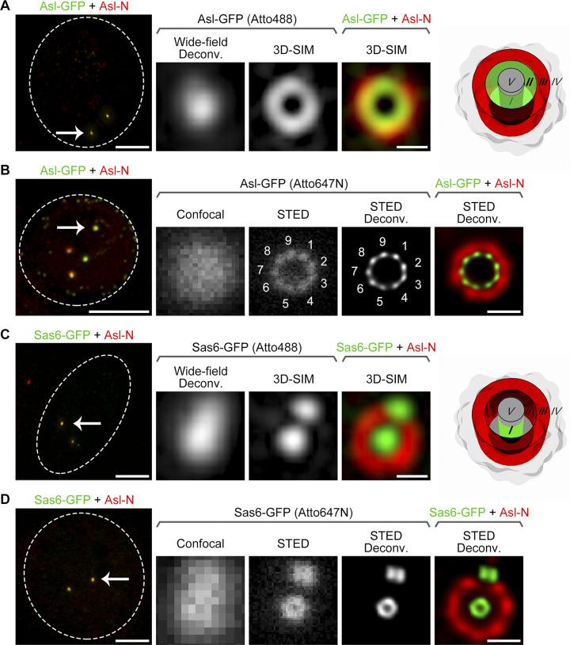
(A) D.Mel-2 cells constitutively expressing Asl-GFP were immunostained with GFP booster Atto488 (green) and antibodies against the N-terminus of Asl (Asl-N; marker for the mother centriole, red) and analyzed using 3D-SIM. The GFP signal at the C-terminus of Asl was identified as a ring in zone II, while the Asl-N signal was located in zone III. The left panel shows the entire cell, with the dashed line indicating the cell boundary, and the arrow marks the centrosome, which is enlarged in the right panels. Scale bar for the cell, 5 µm; for the enlarged centrosome, 200 nm. Wide-field deconvolution, deconvolution of raw 3D-SIM data; 3D-SIM, reconstruction of the same raw data (super-resolution). (B) D.Mel-2 cells constitutively expressing Asl-GFP were immunostained with GFP booster Atto647N (green) and antibodies against Asl-N (red) and analyzed by STED microscopy. Note that the GFP signal at the C-terminus of Asl was resolved into ninefold symmetric densities both in the raw data (STED) and in the deconvolved image (STED Deconv.). The left panel shows the entire cell, with the dashed line indicating the cell boundary, and the arrow marks the centrosome, which is enlarged in the right panels. Scale bar for the cell, 5 µm; for the enlarged centrosome, 200 nm. (C) D.Mel-2 cells constitutively expressing Sas6-GFP were treated as in A. The GFP signal at the C-terminus of Sas6 was

identified as a dot in zone I using 3D-SIM. The left panel shows the entire cell, with the dashed line indicating the cell boundary, and the arrow marks the centrosome, which is enlarged in the right panels. Scale bar for the cell, 5 µm; for the enlarged centrosome, 200 nm. (D) D.Mel-2 cells constitutively expressing Sas6-GFP were treated as in B. The GFP signal at the C-terminus of Sas6 was resolved into a ring using STED microscopy. The left panel shows the entire cell, with the dashed line indicating the cell boundary, and the arrow marks the centrosome, which is enlarged in the right panels. Scale bar for the cell, 5 µm; for the enlarged centrosome, 200 nm.

Figure 2. Pulsed STED laser and detection with temporal synchronization provide improved resolution (Tian et al., 2021)

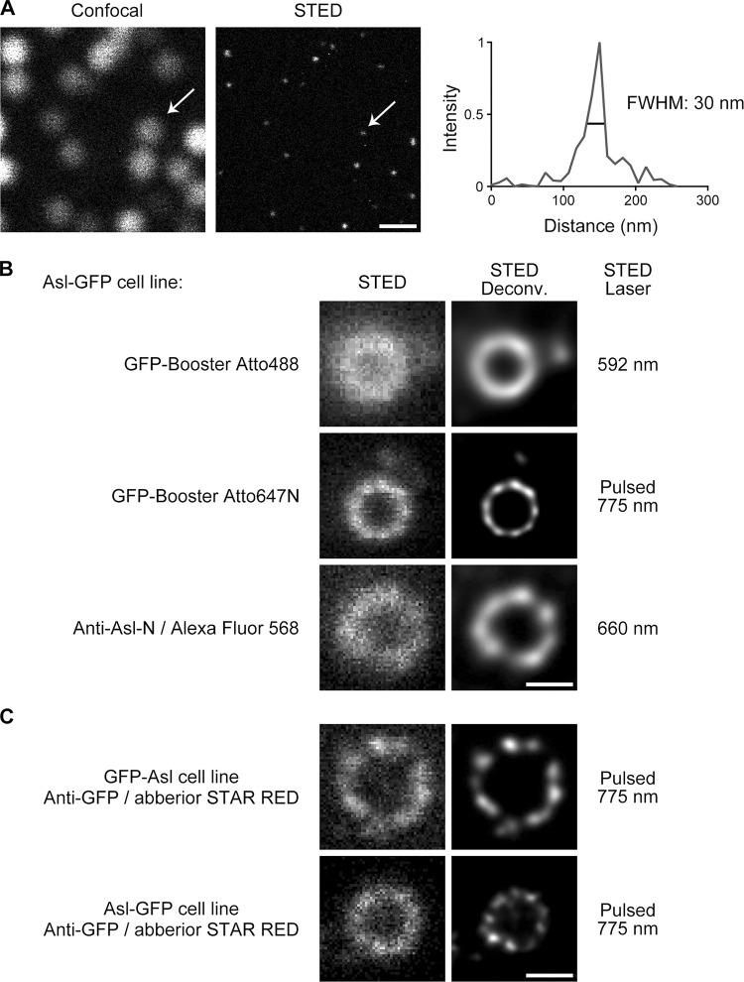
(A) Comparison of confocal and STED raw images of 40-nm red fluorescent nanoparticles. The STED image was acquired using a pulsed STED laser at a wavelength of 775 nm. Arrows indicate a representative nanoparticle, and its STED profile is shown on the right. The average full width at half maximum (FWHM) was measured as 35 ± 7 nm, with n = 33. Scale bar, 500 nm. (B) D.Mel-2 cells constitutively expressing Asl-GFP were

immunostained with GFP booster Atto488, GFP booster Atto647N, or primary antibodies against the N-terminus of Asl (Anti-Asl-N) and secondary antibodies conjugated with Alexa Fluor 568. Note that the pulsed STED laser at 775 nm (targeting Atto647N) provides better resolution than the two other laser lines at 592 nm (targeting Atto488) and 660 nm (targeting Alexa Fluor 568). Scale bar, 200 nm. (C) D.Mel-2 cells constitutively expressing GFP-Asl or Asl-GFP were immunostained with GFP antibodies and secondary antibodies conjugated with Abberior STAR RED. Both the N- and C-termini of Asl were organized into nine discrete signals, resolved by the pulsed STED laser at 775 nm. Scale bar, 200 nm.

Figure 3. Representative STED images of centriole proteins (Tian et al., 2021)

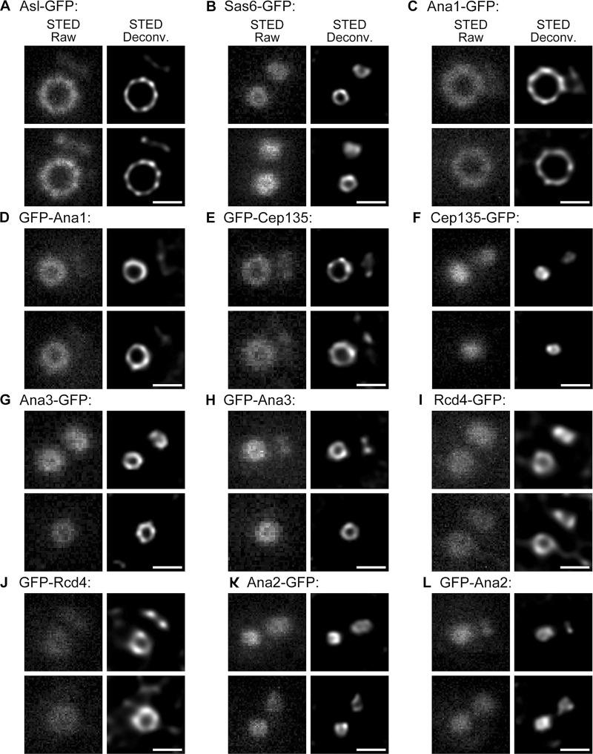
(A–L) D.Mel-2 cells constitutively expressing the indicated GFP-tagged proteins were immunostained with GFP booster Atto647N and antibodies against the N-terminus of Asl (mother centriole marker, not shown) and analyzed using STED microscopy. Raw data are shown in the left panels, and deconvolved images are shown in the right panels. Scale bars, 200 nm.

Figure 4. The N-terminus of Sas6 is resolved as a dot using STED microscopy (Tian et al., 2021)
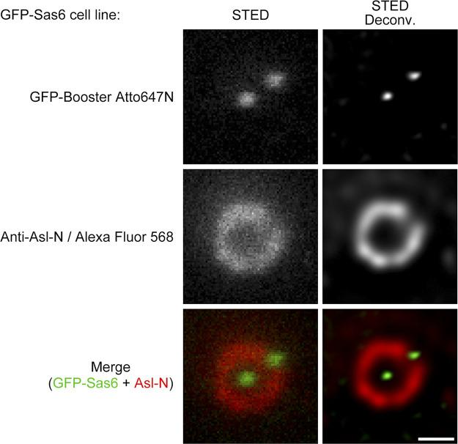
D.Mel-2 cells constitutively expressing GFP-Sas6 were immunostained with GFP booster Atto647N (green) and antibodies against the N-terminus of Asl (Anti-Asl-N; mother centriole marker, red). The N-terminus of Sas6 was resolved as a dot in both raw and deconvolved STED images. Scale bar, 200 nm.

Figure 5. The Cep135–Ana1–Asl axes are organized into ninefold symmetry and overlap with Sas6 (Tian et al., 2021)
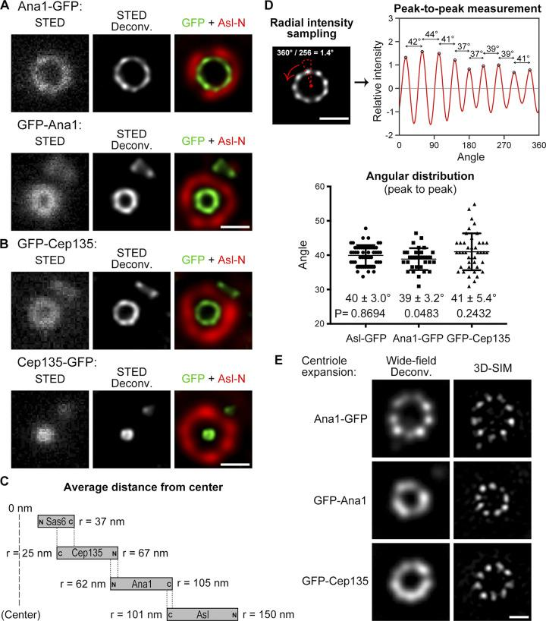
(A and B) D.Mel-2 cells constitutively expressing Ana1 (A) or Cep135 (B), tagged with GFP, were immunostained with GFP booster Atto647N (green) and antibodies against the N-terminus of Asl (Asl-N;

mother centriole marker, red) and analyzed using STED microscopy. Scale bars, 200 nm. (C) Diagrams showing the relative positions of Sas6, Cep135, Ana1, and Asl within a single centriole. The letter "r" indicates the average distance between the end of the protein (each tagged with GFP and stained with GFP booster Atto647N) and the center of the centriole. (D) Angular distributions of intensities from peak to peak for the toroids of Asl-GFP, Ana1-GFP, and GFP-Cep135. The upper panels show data from a single centriole for illustration. The 360° of the centriole are evenly divided into 256 angles, and the intensities in each sector (dashed triangle; radial intensities) were measured and plotted. The distance between adjacent peaks was determined, corresponding to the angular value. Scale bar, 200 nm. The lower panel represents aggregate data; from left to right, n = 53, 33, and 42 peaks. The average angle ± SD (error bars) and p-values are shown under each graph; a two-tailed, one-sample t-test was performed with a null hypothesis angle = 40°. Note that the angular distributions align with the ninefold symmetry corresponding to the 40° angle. (E) D.Mel-2 cells constitutively expressing Ana1-GFP, GFP-Ana1, or GFP-Cep135 were treated using the U-ExM protocol, immunostained with Asl antibodies (mother centriole marker, not shown) and GFP antibodies, and analyzed using 3D-SIM. Note that the centrioles were physically expanded by 4–4.5 times. The ninefold symmetry of Ana1-GFP could be resolved either by deconvolution or by reconstructing the raw 3D-SIM data (Wide-field Deconv. and 3D-SIM, respectively), while the symmetry of GFP-Ana1 and GFP-Cep135 could only be resolved in the reconstructed images. Scale bar, 500 nm.

Figure 6. The C-terminus of Ana1 colocalizes with the microtubule wall (Tian et al., 2021)
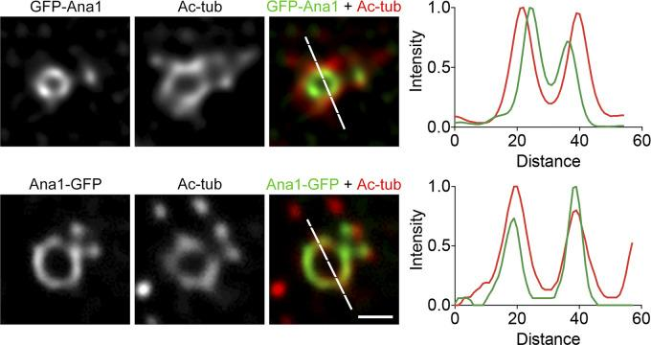

D.Mel-2 cells constitutively expressing GFP-Ana1 or Ana1-GFP were treated with colchicine to depolymerize the cytoplasmic microtubules, immunostained with GFP booster Atto488 (green) and antibodies against acetylated tubulin (Ac-tub, red), and analyzed using STED microscopy. Note that the acetylated tubulin signal colocalizes with Ana1-GFP and is significantly displaced outward compared to the GFP-Ana1 signal. Scale bar, 200 nm.

Figure 7. The Cep135–Ana1–Asl axes extend beyond the microtubule blades (Tian et al., 2021)
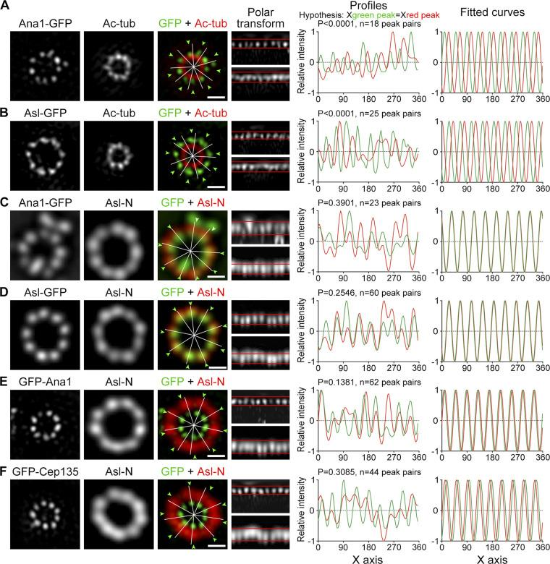
(A and B) D.Mel-2 cells constitutively expressing Ana1-GFP (A) and Asl-GFP (B) were treated with colchicine to depolymerize the cytoplasmic microtubules, processed using the U-ExM protocol, immunostained with GFP antibodies (green) and acetylated tubulin antibodies (Ac-tub, red), and visualized using 3D-SIM. Reconstructed 3D-SIM images were used to analyze the data. Toroid signals were converted to polar coordinates (polar transformation, upper bar for green channel, lower bar for red); intensity profiles were constructed, and the x-coordinate of each green peak was compared with the coordinate of the corresponding red peak using a paired two-tailed Student's t-test (hypothesis: Xgreen peak = Xred peak, with n indicating the number of peak pairs). Both p-values were <0.0001, indicating that the ninefold symmetry of Ana1-GFP and Asl-GFP does not match the symmetry of Ac-tub. Peak intensities were also indicated in the raw toroids (white lines for red signals and arrow tips for green),

and on the right, intensity profiles were fitted to sinusoids. Scale bars, 500 nm. (C–F) D.Mel-2 cells constitutively expressing the indicated GFP-tagged protein were treated with the U-ExM protocol, immunostained with GFP antibodies (green) and the N-terminus of Asl (Asl-N, recognizing amino acids 1–300, red), and visualized using 3D-SIM. Deconvolved images were used for analyzing larger diameter proteins (Asl-N, Ana1-GFP, and Asl-GFP), and reconstructed 3D-SIM images were used for proteins with smaller diameters (GFP-Ana1 and GFP-Cep135). Note that the ninefold distributions of Ana1-GFP, Asl-GFP, GFP-Ana1, and GFP-Cep135 are well aligned with the N-terminus of Asl along the radial axes. Scale bars, 500 nm.

Figure 8. Antibody validation (Tian et al., 2021)

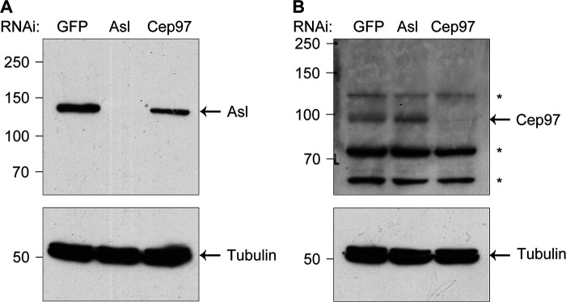
(A and B) D.Mel-2 cells were depleted of GFP (control), endogenous Asl, or Cep97, and whole-cell lysates were analyzed by Western blotting using anti-Asl antibodies (detecting 1–300 amino acids; A) or anti-Cep97 antibodies (detecting 670–806 amino acids; B). Tubulin was used as a loading control. *, nonspecific bands.

Figure 9. Decoration of Sas6–Cep135 axes by Ana2, Ana3, and Rcd4 (Tian et al., 2021)
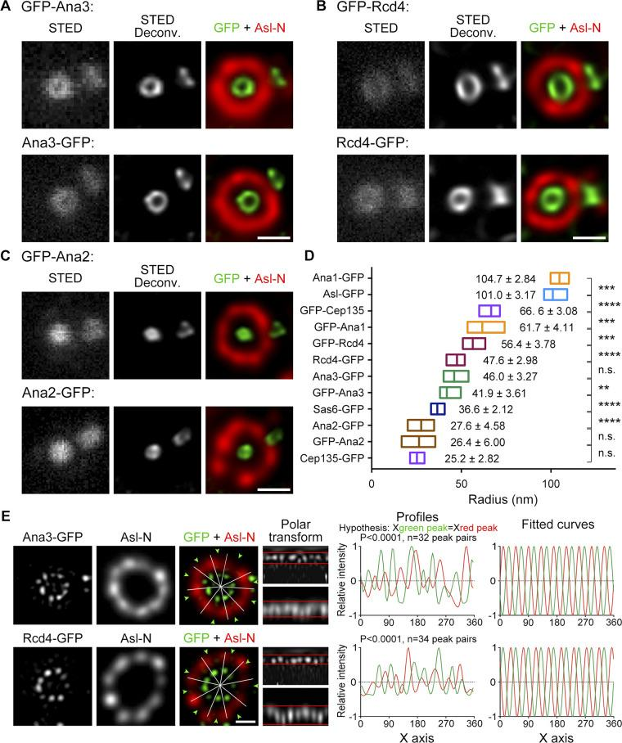

(A–C) D.Mel-2 cells, constitutively expressing Ana3 (A), Rcd4 (B), or Ana2 (C), labeled with GFP, were immunostained with the GFP booster Atto647N (green) and anti-Asl N-terminal antibodies (Asl-N; mother centriole marker, red) and analyzed by STED microscopy. Columns, 200 nm. (D) Average radial distances of various centriole protein domains. The horizontal low-to-high column shows the range of radii, while the vertical line indicates the mean value. The average radius ± SD is shown next to each column. ****, P < 0.0001 (unpaired, two-tailed Student’s t-test); ***, P < 0.001; **, P < 0.01; n.s., not significant. From bottom to top, n = 12, 20, 12, 20, 14, 23, 19, 19, 22, 16, 21, and 17 centrioles, respectively. (E) D.Mel-2 cells, constitutively expressing Ana3-GFP or Rcd4-GFP, were processed using the U-ExM protocol, immunostained with GFP antibodies (green) and Asl-N antibodies (detecting 1–300 amino acids, red), and visualized by 3D-SIM. Deconvolution images were used for analyzing Asl-N and reconstructed 3D-SIM images for Ana3-GFP and Rcd4-GFP. Note that the ninefold distribution of Ana3-GFP and Rcd4-GFP does not match the distribution of Asl-N. Columns, 500 nm.

Figure 10. Ana3 and Rcd4 are distal and partially overlap with Sas6 (Tian et al., 2021)

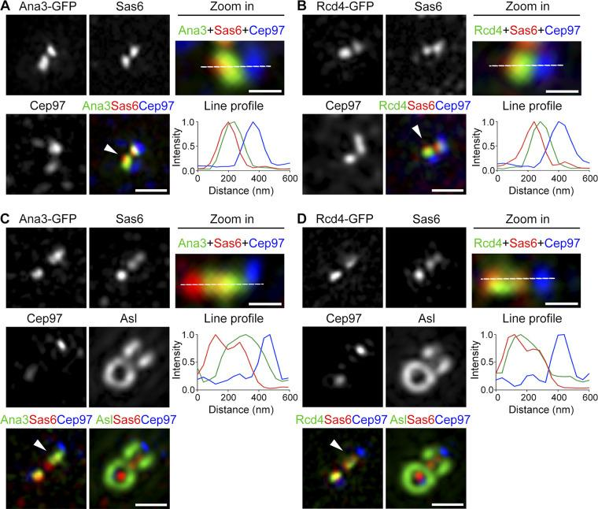
(A and B) D.Mel-2 cells, constitutively expressing Ana3-GFP (A) or Rcd4-GFP (B), were immunostained with the GFP booster Atto488 (green) and antibodies against Sas6 (proximal marker, red) and Cep97 (distal marker, blue). 3D-SIM images showed that Ana3 and Rcd4 largely overlap with Sas6, with their peak intensity shifted toward the distal side of Sas6.

Arrowheads indicate centrioles that were enlarged and measured. Fluorescence intensity along the dashed line drawn on each enlarged image was plotted as a function of distance along the proximal-distal axis. Bars on left panels, 500 nm; for enlarged images, 200 nm. (C and D) Drosophila testes, constitutively expressing Ana3-GFP (C) or Rcd4-GFP (D), were immunostained with GFP booster Atto488 (green) and antibodies against Sas6 (proximal marker, red), Cep97 (distal marker, blue), and Asl (far red channel). 3D-SIM images showed the extended distribution of Sas6 along the centriole longitudinal axis, with Sas6 partially overlapping with Ana3 and Rcd4. Arrowheads indicate centrioles that were enlarged and measured. Fluorescence intensity along the dashed line drawn on each enlarged image was plotted as a function of distance along the proximal-distal axis. Bars on left panels, 500 nm; for enlarged images, 200 nm.

Figure 11. Ana3 is recruited to the centriole after Sas6 and before Rcd4 and Cep135 (Tian et al., 2021)

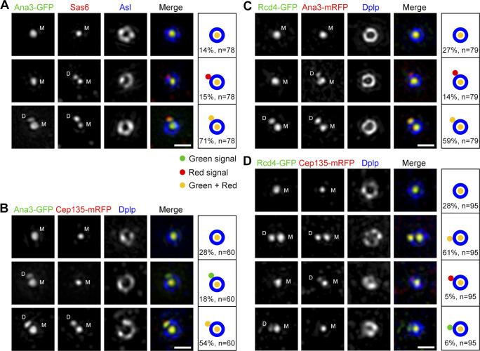
(A) D.Mel-2 cells, constitutively expressing Ana3-GFP, were immunostained with GFP booster Atto488 (green), antibodies against Sas6 (red), and Asl (as a mother centriole marker, blue) and DAPI (DNA staining, not shown). 3D-SIM images showed that 15% (n = 78) of interphase centrosomes have Sas6 signals in both the mother and daughter centrioles, while Ana3 is located only in the mother centriole, indicating that Ana3 is recruited to the daughter centriole later than Sas6. M, mother centriole; D, daughter centriole. Bar, 500 nm. (B–D) D.Mel-2 cells, constitutively expressing Ana3-GFP (B) or Rcd4-GFP (C and D), were transfected with the indicated mRFP-tagged proteins (red) and immunostained with

GFP booster Atto488 (green), anti-Dplp (as a mother centriole marker, blue), and DAPI (not shown). 3D-SIM images showed that Ana3 is recruited to the daughter centriole before Cep135 (B; 18% of interphase centrosomes, n = 60) and Rcd4 (C; 14% of interphase centrosomes, n = 79). Also note the concurrent appearance of Rcd4 and Cep135 in the daughter centriole (D); no apparent hierarchy between these two proteins was observed (n = 95). Columns, 500 nm.

Figure 12. Ana3 and Rcd4 are required for the conversion of a centriole into a centrosome, but not for the initial centriole duplication (Tian et al., 2021)

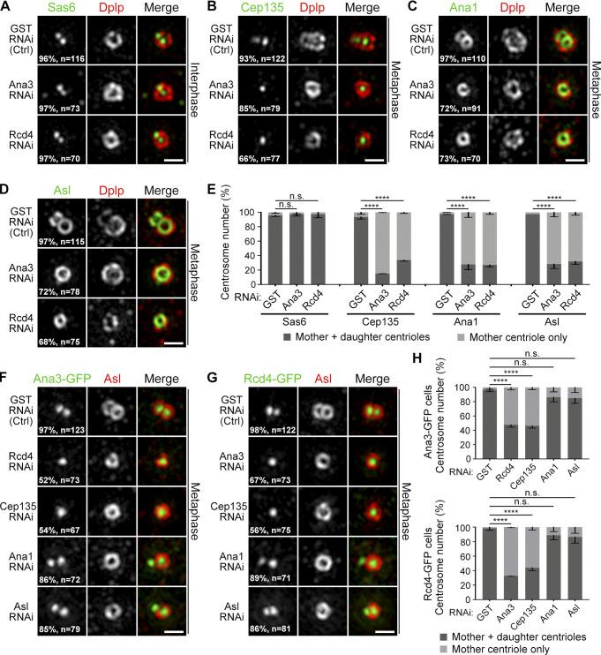
(A) D.Mel-2 cells were depleted of GST (control), endogenous Ana3, or Rcd4 and immunostained for Sas6 (green), Dplp (mother centriole marker, red), and DNA (not shown). Images of cells with a single Dplp signal indicated a disruption in centriole duplication. Nearly all interphase centrosomes contain Sas6 at the site of daughter centriole formation in control and depleted cells. n indicates the total number of centrosomes from three independent experiments. Line, 500 nm. (B–D) D.Mel-2 cells were depleted of GST, endogenous Ana3, or Rcd4 and immunostained to detect the indicated proteins and histone H3 Ser10 phosphorylation (mitotic marker, not shown). Almost all metaphase centrosomes have Cep135 (B), Ana1 (C), and Asl (D) in the daughter centrioles in control cells, while in cells depleted of Ana3 or Rcd4, most show the absence of these three proteins in the

daughter centrioles. n indicates the total number of centrosomes from three independent experiments. Columns, 500 nm. (E) Quantitative assessment of protein recruitment to daughter centrioles in A–D. Error bars indicate SD. ****, P < 0.0001 (unpaired, two-tailed Student’s t-test); n.s., not significant. (F and G) D.Mel-2 cells, constitutively expressing Ana3-GFP (F) or Rcd4-GFP (G), were depleted of the indicated protein. Localization of Ana3 and Rcd4 depends on depletion of each other, Cep135, but not Ana1 or Asl. n indicates the total number of centrosomes from three independent experiments. Columns, 500 nm. (H) Quantitative assessment of protein recruitment to daughter centrioles in F and G. Error bars indicate SD. ****, P < 0.0001 (unpaired, two-tailed Student’s t-test); n.s., not significant.

Figure 13. Diagram illustrating the lateral organization of the centriole scaffold (Tian et al., 2021)

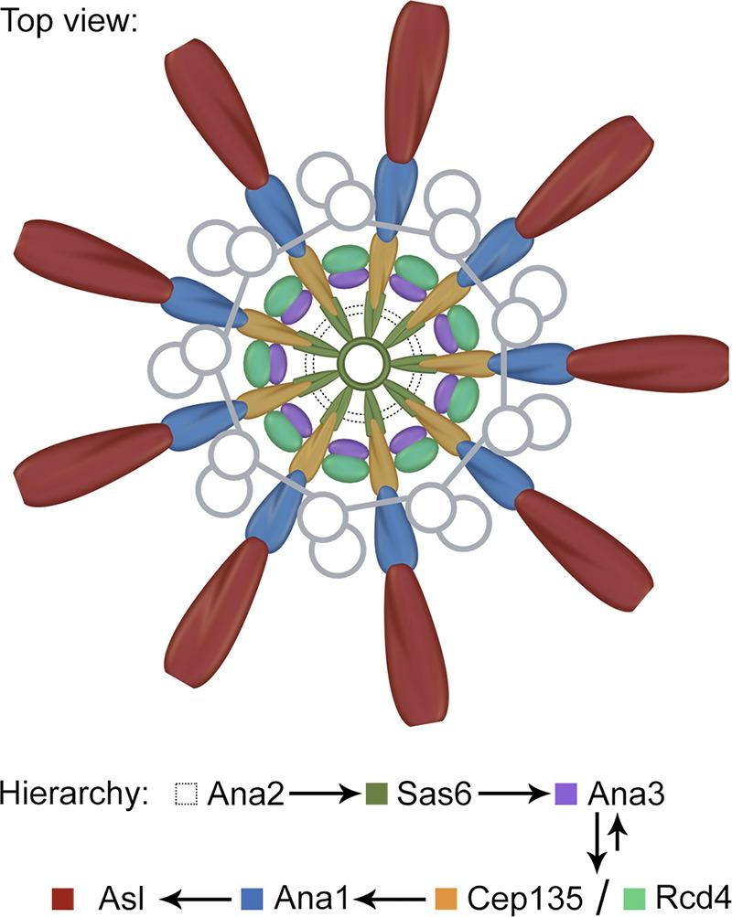
Cep135, Ana1, and Asl are organized in a ninefold symmetry, aligned with each other. Together with Sas6, they form nine radial axes extending from the centriole microtubule wall between the microtubule blades. Ana2, Ana3, and Rcd4 represent a group of compact proteins that likely support these radial axes, with Ana3 and Rcd4 also organized in a ninefold symmetry that does not correspond to the

aforementioned axes. Arrows indicate the hierarchy of these proteins. Ana3 is recruited to the centriole before Rcd4 and Cep135, whereas all three proteins are interdependent for their centriole localization.

Klp10A

Klp10A is a microtubule-depolymerizing kinesin from the kinesin-13 family (Rogers et al., 2004) that was identified as the first centrosomal protein specific to stem cells (Chen et al., 2016). It is localized to the centrosomes of stem cells but not in the centrosomes of differentiating germ cells in the male germline of Drosophila. Depletion of Klp10A led to an abnormally elongated mother centrosome, without affecting other centrosomes (the daughter centrosome in GSCs and any centrosomes in differentiating cells), revealing a unique regulation imposed on the mother centrosome in GSCs. The elongated mother centrosome and normal daughter centrosome in GSCs led to aberrant asymmetry during GSC division, namely a mitotic spindle with a large and small half-spindle, resulting in asymmetric daughter cell sizes (larger GSC and smaller differentiating gonoblasts (GB). Small GBs often die, possibly due to insufficient cellular content for viability. While these results do not uncover the significance of centrosomal asymmetry, they suggest that centrosomal asymmetry may arise due to a complex balance between forces that generate centrosomal asymmetry and forces opposing it. The elongation of the mother centrosome upon Klp10A depletion suggests the existence of a mechanism that continuously elongates the mother centrosome, thus implying a unique mechanism imposed on the mother centrosome, unless it is counteracted by Klp10A. The exact mechanism that Klp10A counters remains unclear.

Alms1a

The Alms1a gene, a homolog of the Drosophila gene that causes the human Alström ciliopathy syndrome (Álvarez-Satta et al., 2015), has been identified as a specific GSC Klp10A interactor (Chen, C., & Yamashita, Y. M., 2020). It was found that Alms1a is a pan-maternal centriole protein, but it also exhibits additional localization in the daughter centriole, particularly within the maternal centrosome of male

GSCs in Drosophila. Remarkably, when Alms1a was depleted, GSCs failed to duplicate their centrioles, leading to the loss of centrosomes in their entire progeny, while the initial maternal centriole in the GSC continued to elongate. Another striking feature of Alms1a’s function is that it is required for centriole duplication only in asymmetrically dividing GSCs, but not in symmetrically dividing GSCs. Alms1a likely facilitates centriole duplication through its interaction with Sak, a Drosophila homolog of the Plk4 kinase, which is a key regulator of centriole duplication (Gönczy, P., & Hatzopoulos, G. N., 2019). These findings again highlight the unique characteristics of the maternal centrosome in GSCs. However, the question remains unresolved as to why the centrosomes of stem cells are asymmetric and distinct from those in non-stem cells.

Ninein

Ninein is localized to the maternal centriole and plays a role in its asymmetry. Mutations in Nin lead to Seckel syndrome in humans. It has been shown that in mouse radial glial progenitor cells, Nin is abundant in the maternal centrosome and is inherited by the radial glial progenitor cells during their asymmetric division. Moreover, Nin is essential for the stereotypical inheritance of the maternal centrosome by these progenitor cells. In Drosophila, it has also been found that Nin is enriched in maternal centrosomes in neuroblasts (NBs) and male GSCs. Depletion of Nin does not significantly affect the divisions or fates of stem cells in Drosophila, leaving the significance of its localization unclear.

While Nin is consistently associated with the maternal centrosome in these cell types, it seemingly does not correlate with cell fate or MTOC (microtubule-organizing center) activity. Maternal centrosomes enriched in Nin are inherited by stem cells in both mouse radial glial progenitors and male GSCs in Drosophila, whereas they are inherited by differentiating daughter cells during Drosophila NB division. Similarly, while maternal centrosomes enriched in Nin have reliable MTOC activity in mouse radial glial progenitors and male GSCs in Drosophila, they suppress MTOC activity in NBs of Drosophila.

Thus, it remains unclear how Nin might contribute to the asymmetric divisions of stem cells.

Conclusion

Asymmetric division of stem cells is a fundamental process for tissue homeostasis, and it is a reliable yet complex event that requires multiple levels of regulation.

Although there are individual examples of fate-determining factors associated with centrosomes, there is still no comprehensive understanding of how centrosomes, in general, can facilitate asymmetric cell division. The asymmetric behavior of both maternal and daughter centrosomes might be utilized to regulate asymmetric cell division and support the distinct needs of various stem cells during development and differentiation. In most cases of asymmetric division, the old molecules and the new centriole are inherited by one sibling cell, which embarks on the path of differentiation, while the new molecules and the old centriole are inherited by the other sibling cell, which maintains stemness.

References:
- Álvarez-Satta, M., Castro-Sánchez, S., & Valverde, D. (2015). Alström syndrome: current perspectives. The application of clinical genetics, 8, 171–179. https://doi.org/10.2147/TACG.S56612
- Anderson, C. T., & Stearns, T. (2009). Centriole age underlies asynchronous primary cilium growth in mammalian cells. Current biology : CB, 19(17), 1498–1502. https://doi.org/10.1016/j.cub.2009.07.034
- Basto, R., Lau, J., Vinogradova, T., Gardiol, A., Woods, C. G., Khodjakov, A., & Raff, J. W. (2006). Flies without centrioles. Cell, 125(7), 1375–1386. https://doi.org/10.1016/j.cell.2006.05.025
- Chen, C., & Yamashita, Y. M. (2020). Alstrom syndrome gene is a stem-cell-specific regulator of centriole duplication in the Drosophila testis. eLife, 9, e59368. https://doi.org/10.7554/eLife.59368
- Chen, C., Inaba, M., Venkei, Z. G., & Yamashita, Y. M. (2016). Klp10A, a stem cell centrosome-enriched kinesin, balances asymmetries in Drosophila male germline stem cell division. eLife, 5, e20977. https://doi.org/10.7554/eLife.20977
- Chichinadze, K. N., & Tkemaladze, D. V. (2008). Centrosomal hypothesis of cellular aging and differentiation. Advances in Gerontology= Uspekhi Gerontologii, 21(3), 367-371.

- Chichinadze, K., Lazarashvili, A., & Tkemaladze, J. (2013). RNA in centrosomes: structure and possible functions. Protoplasma, 250(1), 397-405.
- Chichinadze, K., Tkemaladze, D., & Lazarashvili, A. (2012). New class of RNA and centrosomal hypothesis of cell aging. Advances in Gerontology= Uspekhi Gerontologii, 25(1), 23-28.
- Chichinadze, K., Tkemaladze, J., & Lazarashvili, A. (2012). A new class of RNAs and the centrosomal hypothesis of cell aging. Advances in Gerontology, 2(4), 287-291.
- Chichinadze, K., Tkemaladze, J., & Lazarashvili, A. (2012). Discovery of centrosomal RNA and centrosomal hypothesis of cellular ageing and differentiation. Nucleosides, Nucleotides and Nucleic Acids, 31(3), 172-183.
- Conduit, P. T., Wainman, A., & Raff, J. W. (2015). Centrosome function and assembly in animal cells. Nature reviews. Molecular cell biology, 16(10), 611–624. https://doi.org/10.1038/nrm4062
- Dionne, L. K., Wang, X. J., & Prekeris, R. (2015). Midbody: from cellular junk to regulator of cell polarity and cell fate. Current opinion in cell biology, 35, 51–58. https://doi.org/10.1016/j.ceb.2015.04.010
- Ettinger, A. W., Wilsch-Bräuninger, M., Marzesco, A. M., Bickle, M., Lohmann, A., Maliga, Z., Karbanová, J., Corbeil, D., Hyman, A. A., & Huttner, W. B. (2011). Proliferating versus differentiating stem and cancer cells exhibit distinct midbody-release behaviour. Nature communications, 2, 503. https://doi.org/10.1038/ncomms1511
- Fu, J., Hagan, I. M., & Glover, D. M. (2015). The centrosome and its duplication cycle. Cold Spring Harbor perspectives in biology, 7(2), a015800. https://doi.org/10.1101/cshperspect.a015800
- Fuentealba, L. C., Eivers, E., Geissert, D., Taelman, V., & De Robertis, E. M. (2008). Asymmetric mitosis: Unequal segregation of proteins destined for degradation. Proceedings of the National Academy of Sciences of the United States of America, 105(22), 7732–7737. https://doi.org/10.1073/pnas.0803027105
- Gallaud, E., Pham, T., & Cabernard, C. (2017). Drosophila melanogaster Neuroblasts: A Model for Asymmetric Stem Cell Divisions. Results and problems in cell differentiation, 61, 183–210. https://doi.org/10.1007/978-3-319-53150-2_8
- Gallaud, E., Ramdas Nair, A., Horsley, N., Monnard, A., Singh, P., Pham, T. T., Salvador Garcia, D., Ferrand, A., & Cabernard, C. (2020). Dynamic centriolar localization of Polo and Centrobin in early mitosis primes centrosome asymmetry. PLoS biology, 18(8), e3000762. https://doi.org/10.1371/journal.pbio.3000762
- Ganley, A. R., & Kobayashi, T. (2014). Ribosomal DNA and cellular senescence: new evidence supporting the connection between rDNA and aging. FEMS yeast research, 14(1), 49–59. https://doi.org/10.1111/1567-1364.12133

- Gönczy, P., & Hatzopoulos, G. N. (2019). Centriole assembly at a glance. Journal of cell science, 132(4), jcs228833. https://doi.org/10.1242/jcs.228833
- Gromley, A., Yeaman, C., Rosa, J., Redick, S., Chen, C. T., Mirabelle, S., Guha, M., Sillibourne, J., & Doxsey, S. J. (2005). Centriolin anchoring of exocyst and SNARE complexes at the midbody is required for secretory-vesicle-mediated abscission. Cell, 123(1), 75–87. https://doi.org/10.1016/j.cell.2005.07.027
- Homem, C. C., & Knoblich, J. A. (2012). Drosophila neuroblasts: a model for stem cell biology. Development (Cambridge, England), 139(23), 4297–4310. https://doi.org/10.1242/dev.080515
- Jaba, T. (2022). Dasatinib and quercetin: short-term simultaneous administration yields senolytic effect in humans. Issues and Developments in Medicine and Medical Research Vol. 2, 22-31.
- Januschke, J., Llamazares, S., Reina, J., & Gonzalez, C. (2011). Drosophila neuroblasts retain the daughter centrosome. Nature communications, 2, 243. https://doi.org/10.1038/ncomms1245
- Januschke, J., Llamazares, S., Reina, J., & Gonzalez, C. (2011). Drosophila neuroblasts retain the daughter centrosome. Nature communications, 2, 243. https://doi.org/10.1038/ncomms1245
- Khodjakov, A., Cole, R. W., Oakley, B. R., & Rieder, C. L. (2000). Centrosome-independent mitotic spindle formation in vertebrates. Current biology : CB, 10(2), 59–67. https://doi.org/10.1016/s0960-9822(99)00276-6
- Kiger, A. A., Jones, D. L., Schulz, C., Rogers, M. B., & Fuller, M. T. (2001). Stem cell self-renewal specified by JAK-STAT activation in response to a support cell cue. Science (New York, N.Y.), 294(5551), 2542–2545. https://doi.org/10.1126/science.1066707
- Kipshidze, M., & Tkemaladze, J. (2023). Comparative Analysis of drugs that improve the Quality of Life and Life Expectancy. Junior Researchers, 1(1), 184–193. doi: https://doi.org/10.52340/2023.01.01.19
- Kipshidze, M., & Tkemaladze, J. (2023). The planaria Schmidtea mediterranea as a model system for the study of stem cell biology. Junior Researchers, 1(1), 194–218. doi: https://doi.org/10.52340/2023.01.01.20
- Kipshidze, M., & Tkemaladze, J. (2024). Abastumani Resort: Balneological Heritage and Modern Potential. Junior Researchers, 2(2), 126–134. doi: https://doi.org/10.52340/jr.2024.02.02.12
- Kipshidze, M., & Tkemaladze, J. (2024). Balneology in Georgia: traditions and modern situation. Junior Researchers, 2(2), 78–97. doi: https://doi.org/10.52340/jr.2024.02.02.09
- Kipshidze, M., & Tkemaladze, J. (2024). Microelementoses - history and current status. Junior Researchers, 2(2), 108–125. doi: https://doi.org/10.52340/jr.2024.02.02.11
- Kumar, D., & Reiter, J. (2021). How the centriole builds its cilium: of mothers, daughters, and the acquisition of appendages. Current opinion in structural biology, 66, 41–48. https://doi.org/10.1016/j.sbi.2020.09.006

- Lambert, J. D., & Nagy, L. M. (2002). Asymmetric inheritance of centrosomally localized mRNAs during embryonic cleavages. Nature, 420(6916), 682–686. https://doi.org/10.1038/nature01241
- Lång, E., Połeć, A., Lång, A., Valk, M., Blicher, P., Rowe, A. D., Tønseth, K. A., Jackson, C. J., Utheim, T. P., Janssen, L. M. C., Eriksson, J., & Bøe, S. O. (2018). Coordinated collective migration and asymmetric cell division in confluent human keratinocytes without wounding. Nature communications, 9(1), 3665. https://doi.org/10.1038/s41467-018-05578-7
- Lange, B. M., & Gull, K. (1995). A molecular marker for centriole maturation in the mammalian cell cycle. The Journal of cell biology, 130(4), 919–927. https://doi.org/10.1083/jcb.130.4.919
- Lezhava, T., Monaselidze, J., Jokhadze, T., Kakauridze, N., Khodeli, N., Rogava, M., Tkemaladze, J., ... & Gaiozishvili, M. (2011). Gerontology research in Georgia. Biogerontology, 12, 87-91. doi: 10.1007/s10522-010-9283-6. Epub 2010 May 18. PMID: 20480236; PMCID: PMC3063552
- Losick, V. P., Morris, L. X., Fox, D. T., & Spradling, A. (2011). Drosophila stem cell niches: a decade of discovery suggests a unified view of stem cell regulation. Developmental cell, 21(1), 159–171. https://doi.org/10.1016/j.devcel.2011.06.018
- Manzano-López, J., Matellán, L., Álvarez-Llamas, A., Blanco-Mira, J. C., & Monje-Casas, F. (2019). Asymmetric inheritance of spindle microtubule-organizing centres preserves replicative lifespan. Nature cell biology, 21(8), 952–965. https://doi.org/10.1038/s41556-019-0364-8
- Matsaberidze, M., Prangishvili, A., Gasitashvili, Z., Chichinadze, K., & Tkemaladze, J. (2017). TO TOPOLOGY OF ANTI-TERRORIST AND ANTI-CRIMINAL TECHNOLOGY FOR EDUCATIONAL PROGRAMS. International Journal of Terrorism & Political Hot Spots, 12.
- Moore, D. L., Pilz, G. A., Araúzo-Bravo, M. J., Barral, Y., & Jessberger, S. (2015). A mechanism for the segregation of age in mammalian neural stem cells. Science (New York, N.Y.), 349(6254), 1334–1338. https://doi.org/10.1126/science.aac9868
- Nigg, E. A., & Holland, A. J. (2018). Once and only once: mechanisms of centriole duplication and their deregulation in disease. Nature reviews. Molecular cell biology, 19(5), 297–312. https://doi.org/10.1038/nrm.2017.127
- Nigg, E. A., & Raff, J. W. (2009). Centrioles, centrosomes, and cilia in health and disease. Cell, 139(4), 663–678. https://doi.org/10.1016/j.cell.2009.10.036
- Paridaen, J. T., Wilsch-Bräuninger, M., & Huttner, W. B. (2013). Asymmetric inheritance of centrosome-associated primary cilium membrane directs ciliogenesis after cell division. Cell, 155(2), 333–344. https://doi.org/10.1016/j.cell.2013.08.060
- Pereira, G., Tanaka, T. U., Nasmyth, K., & Schiebel, E. (2001). Modes of spindle pole body inheritance and segregation of the Bfa1p-Bub2p checkpoint protein

complex. The EMBO journal, 20(22), 6359–6370. https://doi.org/10.1093/emboj/20.22.6359
- Prangishvili, A., Gasitashvili, Z., Matsaberidze, M., Chkhartishvili, L., Chichinadze, K., Tkemaladze, J., ... & Azmaiparashvili, Z. (2019). SYSTEM COMPONENTS OF HEALTH AND INNOVATION FOR THE ORGANIZATION OF NANO-BIOMEDIC ECOSYSTEM TECHNOLOGICAL PLATFORM. Current Politics and Economics of Russia, Eastern and Central Europe, 34(2/3), 299-305.
- Rogers, G. C., Rogers, S. L., Schwimmer, T. A., Ems-McClung, S. C., Walczak, C. E., Vale, R. D., Scholey, J. M., & Sharp, D. J. (2004). Two mitotic kinesins cooperate to drive sister chromatid separation during anaphase. Nature, 427(6972), 364–370. https://doi.org/10.1038/nature02256
- Rusan, N. M., & Peifer, M. (2007). A role for a novel centrosome cycle in asymmetric cell division. The Journal of cell biology, 177(1), 13–20. https://doi.org/10.1083/jcb.200612140
- Salzmann, V., Chen, C., Chiang, C. Y., Tiyaboonchai, A., Mayer, M., & Yamashita, Y. M. (2014). Centrosome-dependent asymmetric inheritance of the midbody ring in Drosophila germline stem cell division. Molecular biology of the cell, 25(2), 267–275. https://doi.org/10.1091/mbc.E13-09-0541
- Shcheprova, Z., Baldi, S., Frei, S. B., Gonnet, G., & Barral, Y. (2008). A mechanism for asymmetric segregation of age during yeast budding. Nature, 454(7205), 728–734. https://doi.org/10.1038/nature07212
- Singh, P., Ramdas Nair, A., & Cabernard, C. (2014). The centriolar protein Bld10/Cep135 is required to establish centrosome asymmetry in Drosophila neuroblasts. Current biology : CB, 24(13), 1548–1555. https://doi.org/10.1016/j.cub.2014.05.050
- Sunchu, B., & Cabernard, C. (2020). Principles and mechanisms of asymmetric cell division. Development (Cambridge, England), 147(13), dev167650. https://doi.org/10.1242/dev.167650
- Tian, Y., Wei, C., He, J., Yan, Y., Pang, N., Fang, X., Liang, X., & Fu, J. (2021). Superresolution characterization of core centriole architecture. The Journal of cell biology, 220(4), e202005103. https://doi.org/10.1083/jcb.202005103
- Tkemaladze J. (2024). Editorial: Molecular mechanism of ageing and therapeutic advances through targeting glycative and oxidative stress. Front Pharmacol. 2024 Mar 6;14:1324446. doi: 10.3389/fphar.2023.1324446. PMID: 38510429; PMCID: PMC10953819.
- Tkemaladze, J. (2023). Cross-senolytic effects of dasatinib and quercetin in humans. Georgian Scientists, 5(3), 138–152. doi: https://doi.org/10.52340/2023.05.03.15
- Tkemaladze, J. (2023). Is the selective accumulation of oldest centrioles in stem cells the main cause of organism ageing?. Georgian Scientists, 5(3), 216–235. doi: https://doi.org/10.52340/2023.05.03.22

- Tkemaladze, J. (2023). Long-Term Differences between Regenerations of Head and Tail Fragments in Schmidtea Mediterranea Ciw4. Available at SSRN 4257823.
- Tkemaladze, J. (2023). Reduction, proliferation, and differentiation defects of stem cells over time: a consequence of selective accumulation of old centrioles in the stem cells?. Molecular Biology Reports, 50(3), 2751-2761.
- Tkemaladze, J. (2023). Structure and possible functions of centriolar RNA with reference to the centriolar hypothesis of differentiation and replicative senescence. Junior Researchers, 1(1), 156–170. doi: https://doi.org/10.52340/2023.01.01.17
- Tkemaladze, J. (2023). The centriolar hypothesis of differentiation and replicative senescence. Junior Researchers, 1(1), 123–141. doi: https://doi.org/10.52340/2023.01.01.15
- Tkemaladze, J. (2024). Absence of centrioles and regenerative potential of planaria. Georgian Scientists, 6(4), 59–75. doi: https://doi.org/10.52340/gs.2024.06.04.08
- Tkemaladze, J. (2024). Cell center and the problem of accumulation of oldest centrioles in stem cells. Georgian Scientists, 6(2), 304–322. doi: https://doi.org/10.52340/gs.2024.06.02.32
- Tkemaladze, J. (2024). Elimination of centrioles. Georgian Scientists, 6(4), 291–307. doi: https://doi.org/10.52340/gs.2024.06.04.25
- Tkemaladze, J. (2024). Main causes of intelligence decrease and prospects for treatment. Georgian Scientists, 6(2), 425–432. doi: https://doi.org/10.52340/gs.2024.06.02.44
- Tkemaladze, J. (2024). The rate of stem cell division decreases with age. Georgian Scientists, 6(4), 228–242. doi: https://doi.org/10.52340/gs.2024.06.04.21
- Tkemaladze, J. (2025). A Universal Approach to Curing All Diseases: From Theoretical Foundations to the Prospects of Applying Modern Biotechnologies in Future Medicine. doi: http://dx.doi.org/10.13140/RG.2.2.24481.11366
- Tkemaladze, J. (2025). Strategic Importance of the Caucasian Bridge and Global Power Rivalries. doi: http://dx.doi.org/10.13140/RG.2.2.19153.03680
- Tkemaladze, J. (2025). The Epistemological Reconfiguration and Transubstantial Reinterpretation of Eucharistic Practices Established by the Divine Figure of Jesus Christ in Relation to Theological Paradigms. doi: http://dx.doi.org/10.13140/RG.2.2.28347.73769
- Tkemaladze, J. (2025). Transforming the psyche with phoneme frequencies "Habere aliam linguam est possidere secundam animam" Charlemagne. doi: http://dx.doi.org/10.13140/RG.2.2.16105.61286
- Tkemaladze, J. (2025). Anatomy, Biogenesis, and Role in Cell Biology of Centrioles. Longevity Horizons, 1(2). doi: https://doi.org/10.5281/zenodo.14742232
- Tkemaladze, J. (2025). Concept to The Alive Language. Longevity Horizons, 1(1). doi: https://doi.org/10.5281/zenodo.14688792

- Tkemaladze, J. (2025). Concept to The Caucasian Bridge. Longevity Horizons, 1(1). doi: https://doi.org/10.5281/zenodo.14689276
- Tkemaladze, J. (2025). Concept to The Curing All Diseases. Longevity Horizons, 1(1). doi: https://doi.org/10.5281/zenodo.14676208
- Tkemaladze, J. (2025). Concept to The Eternal Youth. Longevity Horizons, 1(1). doi: https://doi.org/10.5281/zenodo.14681902
- Tkemaladze, J. (2025). Concept to The Food Security. Longevity Horizons, 1(1). doi: https://doi.org/10.5281/zenodo.14642407
- Tkemaladze, J. (2025). Concept to the Living Space. Longevity Horizons, 1(1). doi: https://doi.org/10.5281/zenodo.14635991
- Tkemaladze, J. (2025). Concept to The Restoring Dogmas. Longevity Horizons, 1(1). doi: https://doi.org/10.5281/zenodo.14708980
- Tkemaladze, J. (2025). Differentiation of Somatic Cells in Multicellular Organisms. Longevity Horizons, 1(2). doi: https://doi.org/10.5281/10.5281/zenodo.14778927
- Tkemaladze, J. (2025). Replicative Hayflick Limit. Longevity Horizons, 1(2). doi: https://doi.org/10.5281/zenodo.14752664
- Tkemaladze, J. (2025). Solutions to the Living Space Problem to Overcome the Fear of Resurrection from the Dead. doi: http://dx.doi.org/10.13140/RG.2.2.34655.57768
- Tkemaladze, J. (2025). The Concept of Data-Driven Automated Governance. Georgian Scientists, 6(4), 399–410. doi: https://doi.org/10.52340/gs.2024.06.04.38
- Tkemaladze, J. (2025).Achieving Perpetual Vitality Through Innovation. doi: http://dx.doi.org/10.13140/RG.2.2.31113.35685
- Tkemaladze, J. (2025).Systemic Resilience and Sustainable Nutritional Paradigms in Anthropogenic Ecosystems. doi: http://dx.doi.org/10.13140/RG.2.2.18943.32169/1
- Tkemaladze, J. V., & Chichinadze, K. N. (2005). Centriolar mechanisms of differentiation and replicative aging of higher animal cells. Biochemistry (Moscow), 70, 1288-1303.
- Tkemaladze, J., & Apkhazava, D. (2019). Dasatinib and quercetin: short-term simultaneous administration improves physical capacity in human. J Biomedical Sci, 8(3), 3.
- Tkemaladze, J., & Chichinadze, K. (2005). Potential role of centrioles in determining the morphogenetic status of animal somatic cells. Cell biology international, 29(5), 370-374.
- Tkemaladze, J., & Chichinadze, K. (2010). Centriole, differentiation, and senescence. Rejuvenation research, 13(2-3), 339-342.
- Tkemaladze, J., & Samanishvili, T. (2024). Mineral ice cream improves recovery of muscle functions after exercise. Georgian Scientists, 6(2), 36–50. doi: https://doi.org/10.52340/gs.2024.06.02.04

- Tkemaladze, J., Tavartkiladze, A., & Chichinadze, K. (2012). Programming and Implementation of Age-Related Changes. In Senescence. IntechOpen.
- Tkemaladze, Jaba and Kipshidze, Mariam, Regeneration Potential of the Schmidtea Mediterranea CIW4 Planarian. Available at SSRN: https://ssrn.com/abstract=4633202 or http://dx.doi.org/10.2139/ssrn.4633202
- Tozer, S., Baek, C., Fischer, E., Goiame, R., & Morin, X. (2017). Differential Routing of Mindbomb1 via Centriolar Satellites Regulates Asymmetric Divisions of Neural Progenitors. Neuron, 93(3), 542–551.e4. https://doi.org/10.1016/j.neuron.2016.12.042
- Venkei, Z. G., & Yamashita, Y. M. (2018). Emerging mechanisms of asymmetric stem cell division. The Journal of cell biology, 217(11), 3785–3795. https://doi.org/10.1083/jcb.201807037
- Wang, X., Le, N., Denoth-Lippuner, A., Barral, Y., & Kroschewski, R. (2016). Asymmetric partitioning of transfected DNA during mammalian cell division. Proceedings of the National Academy of Sciences of the United States of America, 113(26), 7177–7182. https://doi.org/10.1073/pnas.1606091113
- Wang, X., Tsai, J. W., Imai, J. H., Lian, W. N., Vallee, R. B., & Shi, S. H. (2009). Asymmetric centrosome inheritance maintains neural progenitors in the neocortex. Nature, 461(7266), 947–955. https://doi.org/10.1038/nature08435
- Yamashita, Y. M., Jones, D. L., & Fuller, M. T. (2003). Orientation of asymmetric stem cell division by the APC tumor suppressor and centrosome. Science (New York, N.Y.), 301(5639), 1547–1550. https://doi.org/10.1126/science.1087795
- Yamashita, Y. M., Mahowald, A. P., Perlin, J. R., & Fuller, M. T. (2007). Asymmetric inheritance of mother versus daughter centrosome in stem cell division. Science (New York, N.Y.), 315(5811), 518–521. https://doi.org/10.1126/science.1134910
- Прангишвили, А. И., Гаситашвили, З. А., Мацаберидзе, М. И., Чичинадзе, К. Н., Ткемаладзе, Д. В., & Азмайпарашвили, З. А. (2017). К топологии антитеррористических и антикриминальных технологии для образовательных программ. В научном издании представлены материалы Десятой международной научно-технической конфе-ренции «Управление развитием крупномасштабных систем (MLSD’2016)» по следующим направле-ниям:• Проблемы управления развитием крупномасштабных систем, включая ТНК, Госхолдин-ги и Гос-корпорации., 284.
- Прангишвили, А. И., Гаситашвили, З. А., Мацаберидзе, М. И., Чхартишвили, Л. С., Чичинадзе, К. Н., & Ткемаладзе, Д. В. (2017). & Азмайпарашвили, ЗА (2017). Системные составляющие здравоохранения и инноваций для организации европейской нано-биомедицинской екосистемной технологической платформы. Управление развитием крупномасштабных систем MLSD, 365-368.

- Ткемаладзе, Д. (2025). Анатомия, биогенез и роль в клеточной биологии центриолей. doi: http://dx.doi.org/10.13140/RG.2.2.27441.70245/1
- Ткемаладзе, Д. (2025). Дифференциация соматических клеток многоклеточных животных. doi: http://dx.doi.org/10.13140/RG.2.2.23348.97929/1
- Ткемаладзе, Д. (2025). Репликативный Лимит Хейфлика. doi: http://dx.doi.org/10.13140/RG.2.2.25803.30249
- Ткемаладзе, Д. В., & Чичинадзе, К. Н. (2005). Центриолярные механизмы дифференцировки и репликативного старения клеток высших животных. Биохимия, 70(11), 1566-1584.

- Ткемаладзе, Д., Цомаиа, Г., & Жоржолиани, И. (2001). Создание искусственных самоадаптирующихся систем на основе Теории Прогноза. Искусственный интеллект. УДК 004.89. Искусственный интеллект. УДК 004.89.
- Чичинадзе, К. Н., & Ткемаладзе, Д. В. (2008). Центросомная гипотеза клеточного старения и дифференциации. Успехи геронтологии, 21(3), 367-371.
- Чичинадзе, К., Ткемаладзе, Д., & Лазарашвили, А. (2012). НОВЫЙ КЛАСС РНК И ЦЕНТРОСОМНАЯ ГИПОТЕЗА СТАРЕНИЯ КЛЕТОК. Успехи геронтологии, 25(1), 23-28.

